Please report this news immediately
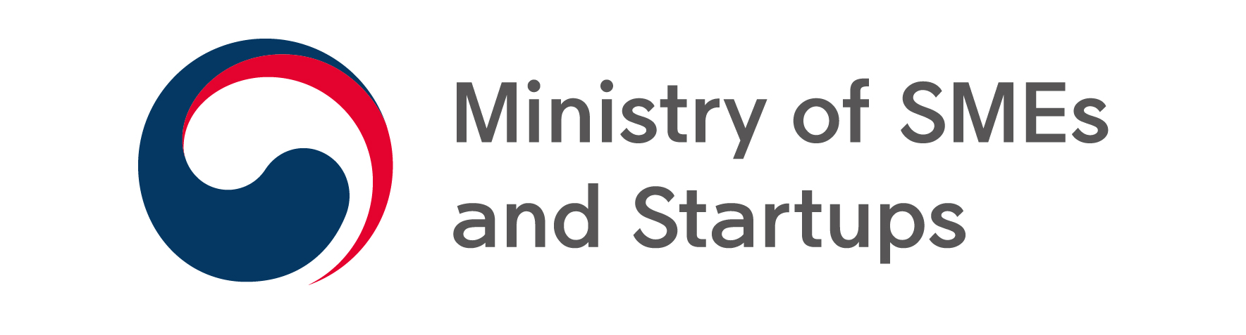 | Press release | 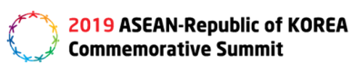
∙Inquiry: Manager Jeong Jae-hoon of the Ministry of SMEs and Startups in charge of overseas markets (042-481-4391), and Officer Gong Yun (1656).
Leader (044-202-2963) of Medical Devices and Cosmetics Industry TF team of Ministry of Health and Welfare's ; Officer Nam Ji-won (2965)
Manager Choi Mi-ra of Cosmetics Policy department of Ministry of Food and Drug Safety's (043-719-3401), Officer Kim Min-jung(3404).
General director Jeong Jae-in of the Global Cooperation Department of big, medium and Small Business Agricultural and Fishery Cooperation Foundation (02-368-8760)
K-beauty, A vigorous leap forward globally with ASEAN's beauty

- The venue of Korean-Asean festival, ‘ASEAN-ROK K-Beauty Festival' hosted

□ Show K-beauty's power, including displaying popular beauty products and 3D mask packs from Brand K and SMEs, and also present various cooperative models of Korea and Asia.
□ Uplift the festive mood by providing a variety of rich things to see, such as public broadcasting of 'Get it Beauty', K-beauty trend show, and hair and makeup demonstration.

Ministry of SMEs and Startups (Minister Park Young-sun, hereinafter referred to as MSS) declared, "The K-Beauty Festival(hereinafter referred to as the event)," a representative event for small and medium-sized enterprises of the Korea-ASEAN Special Summit (11.24.-11.26), will be held in BEXCO, Busan, on Nov. 25 and 26.
The related ministries, government-related agencies, including the Ministry of Health and Welfare, the Ministry of Food and Drug Safety and K-beauty companies will participate in this event held under the slogan "ASEAN Beauty, Make Up Our Dreams,"

This event is arranged to share Korea-Asean culture and beauty each other with Asian guests, to expand the common value of win-win and prosperity through the connection of Korean Wave (K beauty and K pop).

It is also the venue for the festival, in which various people, including students and multi-cultural families, will become bridges between Korea and ASEAN in a space filled with K-beauty and K-pop, while supporting K-beauty companies leading the global trend.

< Overview of K-beauty festival>
• Date and time: November 25-26, 2019, Hall 1, BEXCO Exhibition Hall 1
• Organized by: Ministry of SMEs and Startups, Ministry of Health and Welfare
• Supervised by: Small and Medium Enterprises Agricultural and Fishery Cooperation Foundation, CJENM, AMOREPACIFIC, SME Distribution Center
• Sponsored by: Korea Food & Drug Administration, Busan, AMOREPACIFIC, Korea Health
Industry Development Institute, Korea Cosmetics Industry Institute,
Korea Cosmetics Association, SME Cosmetics Export Association,
International Beauty Industry Trade Association, Busan Cosmetics Association
• Major Programs
① K-Beauty Exhibition Booth: Small and Medium Business Zone, Korea-ASEAN Zone, Large medium and small business win-win zone, Beauty Experience Zone
② K Beauty Demonstration and Experience Program
ㅇ Get it beauty (public broadcasting), K beauty trend show, hair & makeup demonstration and experience, K beauty experience booth (VR experience, artificial skin 3D printer), skin diagnosis and 3D mask
ㅇ ASEAN international student theme video and K-pop mini concert

The venue will consist of ⓵small and medium-sized businesses where Korea's promising beauty products are displayed, ⓶ Korea-ASEAN Zone that shows various cooperative relations with ASEAN countries, and ⓷Win-win zone that suggests the model of win-win through excellent large, medium and small business products, ⓸ K-beauty experience zone that offers the experience opportunities of high end beauty technologies such as 3D mask, and customized skin diagnosis.

In addition, K-Beauty will show its potential as the world's fourth largest exporter of cosmetics, as well as the possibility of global co-entry through various joint business models between Korea and ASEAN.

MSS will exhibit about 60 SME products, such as 'Brand K *', which leads global trends to promote K-beauty's promising SMEs and enter overseas markets. It supports various publicity and promotion activities such as inviting oversea buyers (20 companies from 4 countries), beauty public broadcasting and SNS promotion.

* Brand K is a system designed to raise awareness and value of SME brands through government certification of SME products with technicality, design and product stability, it plans to select around 300 premium SME products by 2022.
Various companies that will display K-beauty's excellence will participate in the "K-Beauty Festival".

▲ LN Cosmetic Co., Ltd., which achieved cumulative sales of 1.6 billion mask packs as a leading company in the mask pack field, ▲ Ami Cosmetics, which introduced new technology ampoule using ginseng fruit, which is more precious than ginseng, and ▲ Creative With Co., Ltd. a maker of natural shampoo with fine dust cleaning function,
They are all equipped with new technology, safety and global trends.

< Major Sall and medium businesses participated in K beauty festival >
* Mask pack used to be a sample gift until the mid-2000s. However, LNP cosmetics established and marketed the advanced and popular strategy of mask pack reflecting the beauty trend that values skin care. The mask pack has grown to become a single category of cosmetics. It has earned the reputation of being a mask pack sold in 0.1 seconds and has sold cumulative 1.7 billion packs up to now.

* Ami Cosmetics (Representative Lee Kyung-rok) is a Derma Technology specialized cosmetic that has the same level of functions as pharmaceuticals, its quality is certified by using localized product with excellent safety and R&D competitiveness, it also built the research center in Seoul and Jeju, applied for 100 domestic and oversea patents through active research and development, is sold at over 11000 beauty stores at home and oversea.

* Creative With (CEO Lee Ha-min), a naturalistic personal care brand, launched a premium shampoo containing 99 percent natural organic ingredients, completing a human application that is effective in maintaining volume for a long period of time, including fine dust cleaning, reduced scalp sebum, reduced scalp exfoliation, improved hair damage, and about 1.3 million products sold within two years of release

Meanwhile, the event will provide abundant attractions and various experiences to further enhance the mood of festival.

There will be various programs such as Asean representative platform 'Get It Beauty' public broadcasting, K beauty trend show, hair and makeup demonstration, and K beauty experience booth..

K-beauty experience booth will not only demonstrate the production site of raw material for natural cosmetics using virtual reality (VR) but also the technology to manufacture artificial skin, which is used as a new cosmetic evaluation technology after the enforcement of the Animal Experiment Prohibition Act, in real time using a 3D bio printer.
Under the supervision of the Ministry of Health and Welfare, K-beauty trend show, hair and makeup demonstration, and K-beauty experience events will be held, it will be the successful government-industry cooperative model because the Ministry of Food and Drug Safety will operate a K-beauty stability promotion booth.

Minister, Park Young-sun commented the importance of joint prosperity with fast-growing ASEAN since the 30th anniversary of the ASEAN-Korea talk and the 3rd ASEAN-Korea Summit, and emphasized "Our growth to world's 4th cosmetic exporting country is the result of endless new product development effort by beauty small and medium businesses which continue to release products, which never existed in the world, such as BB Cream, Air Cushion Foundation, and Mask Pack"

In addition, she revealed her will, "with this event, we will focus our policy efforts on Korea's leap to become one of the world's top three cosmetics export nations by supporting various global collaboration models and preparing K-beauty support plan with
related ministries such as the Ministry of Health and Welfare, Ministry of Food and Drug Safety.

 | 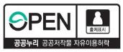 |  |  | For more information regarding this press release, please contact Gong Yun, Official in charge of Overseas Markets at Ministry of SMEs and Startups. (☎ 042-481-1656)
1 |  |  | Overview of event

□ Name of event: ASEAN-ROK K-Beauty Festival

□ Date and time: November,25 (Mon) ~ 26 (Tue), 2019,1 hall of BEXCO Exhibition Hall 1

□ Organizer: Ministry of SMEs and Startups, Ministry of Health and Welfare

ㅇ (Organized by) Large, medium and Small Business and Farming Industry Cooperation Foundation, CJ ENM, Amorepacific, Small Business Distribution Center

ㅇ (Sponsored by) Ministry of Food and Drug Safety, Busan, Korea Cosmetic Industry Research Institute, Korea Health Industry Promotion Agency, Korea Cosmetics & Small Business Export Association, Korea Cosmetics Association, etc.

□ Visitors: About 1,000 visitors who are interested in large and small businesses and K-beauty

ㅇ Overseas buyers (20 companies from 4 countries), Korea-ASEAN international students, multicultural families, cosmetics industry officials, officials of related organizations, the general public, etc.
□ Main program

① Operation of K-beauty Exhibition Booth: Small and Medium Business Zone, Korea-ASEAN Zone, Large, medium and small Business win-win zone
* Operation of beauty booth related to brand K and promotion of brand K enblum

② K-beauty Demonstration and Experience Program
ᄋ Get it Beauty (public broadcasting), trend show, hair, makeup, VR experience,
Artificial skin 3D printer, skin diagnosis, 3D mask

ᄋ ASEAN Student theme Video and K-pop Mini Concert

